# Module – 5 Security

Assignment 1

IAM USER CASE: Creation of IAM account to have Full access to S3 Service

## S3 full access - AWS managed policy: AmazonS3FullAccess

## You can attach the AmazonS3FullAccess policy to your IAM identities. This policy grants permissions that allow full access to Amazon S3.

As per best practice, access should be provided to group hence we created Group and attached the AmazonS3FullAccess policy. To provide this policy privilege to users we will add users to the group.

Below are the steps taken to implement the above task;

Step 1: Search and select ‘IAM’ in search box on AWS Console.

Step 2: Click on ‘**User groups**’ and click on ‘**Create group**’.

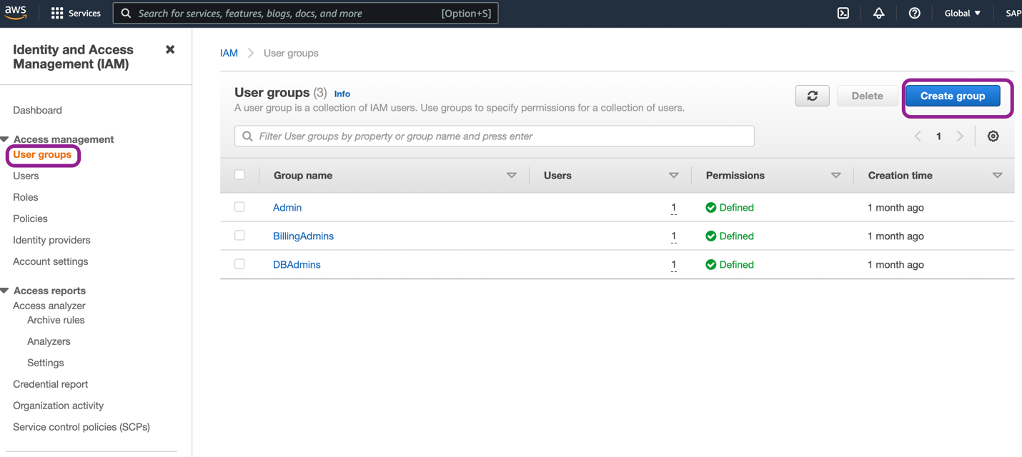

Step 3: Configure below properties:

1. User group name: give the unique name ‘StorageAdmin’ for group.

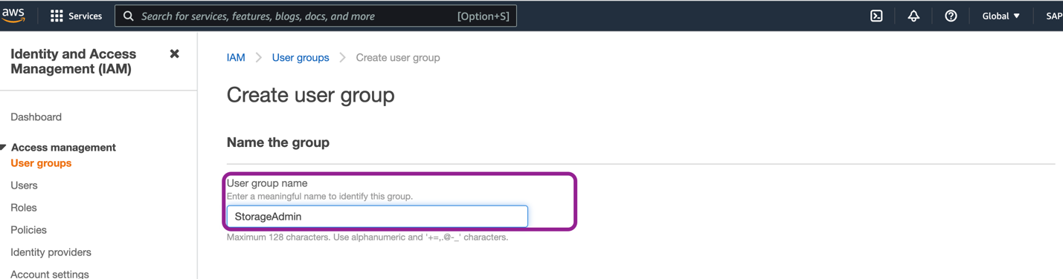

1. Add users to the group: This is optional as users can be added later. But I searched user with name and added.
2. Attach permissions policies: This is optional. With this we can assign the permissions to group. To provide Full S3 permissions, search for S3 and select ‘AmazonS3FullAccess’.

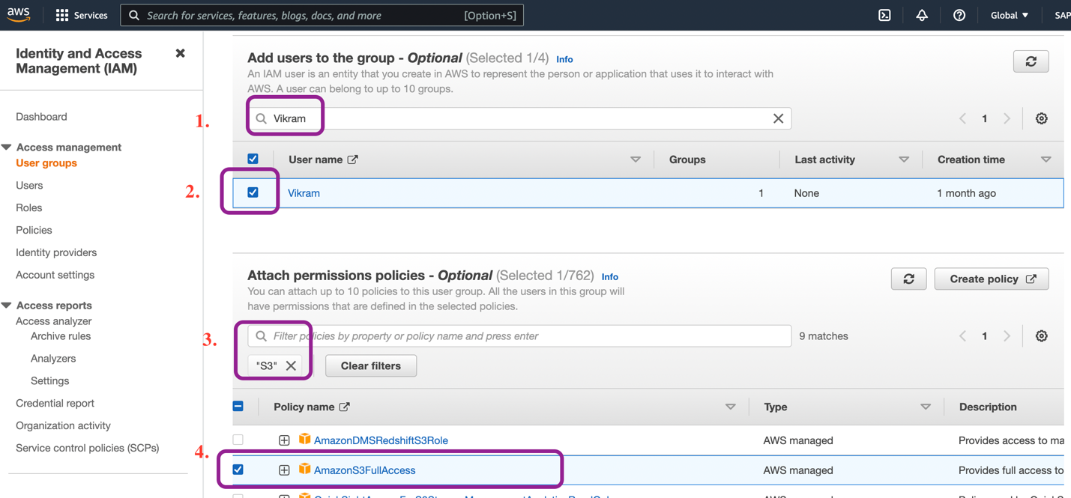

1. Click on ‘Create group’.

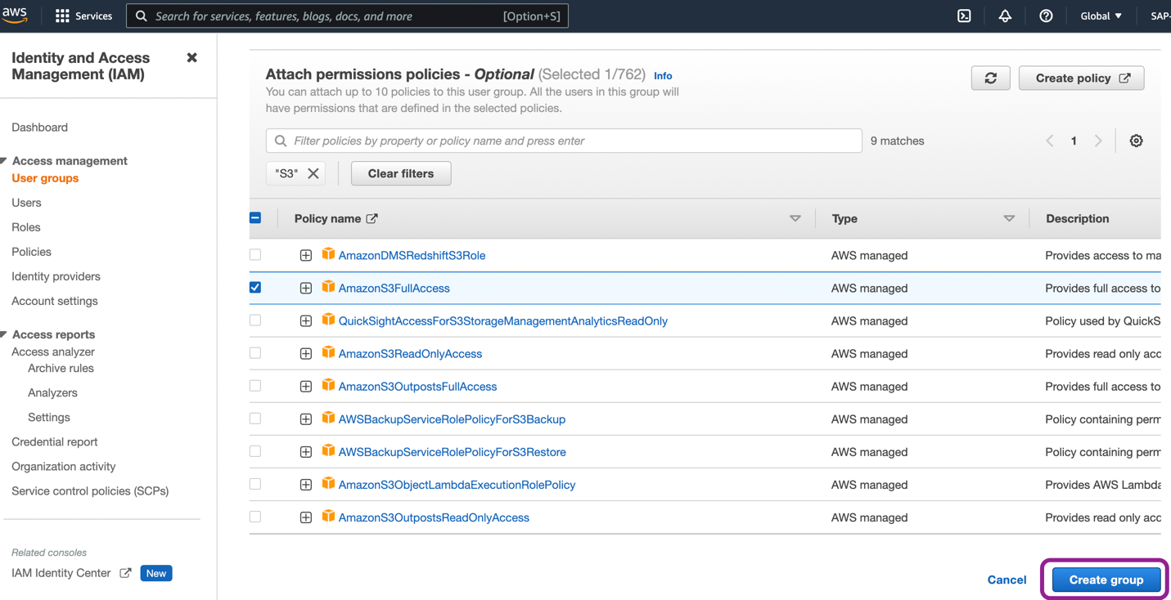

Under ‘User groups’ in left pane, we can check the user group.

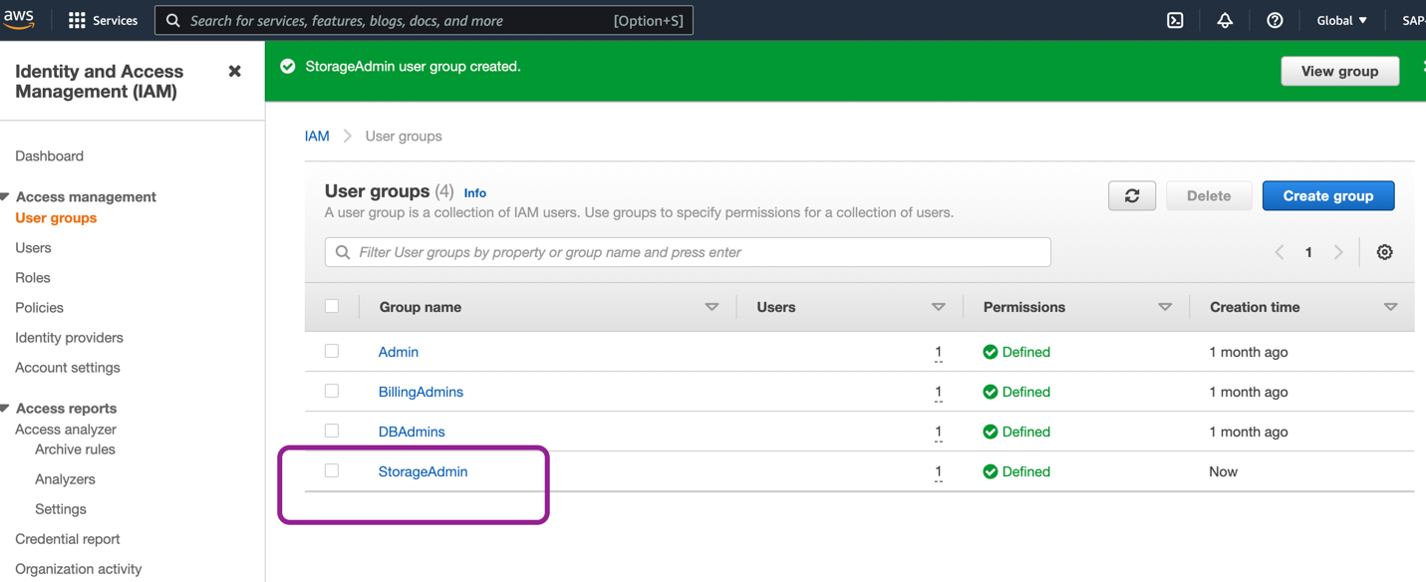

To check the permissions, click on ‘StorageAdmin’ then ‘Permissions’ and then ‘AmazonS3FullAccess’.

As per below policy statements this permission provides full access on S3 and s3-object-Lambda.

